**PROJECT REPORT TEMPLATE**

**I INTRODUCTION**

* 1. **OVERVIEW**

**INVITATION**

The creating captivating birthday invitation with canva project is centered around designing visually appealing and personalized birthday invitation using canva, A well – crafted birthday invitation sets the tone for a memorable celebration and makes recipients feel excited to attend

1**.2 PURPOSE**

Conveys the overall tone of the event they are invited to they are the primary way to get the word out about an event and can help drive event attendance and ticket sales.

1. **PROBLEM DEFINITION AND DESIGN THINKING** 
   1. **EMPATHY MAP**

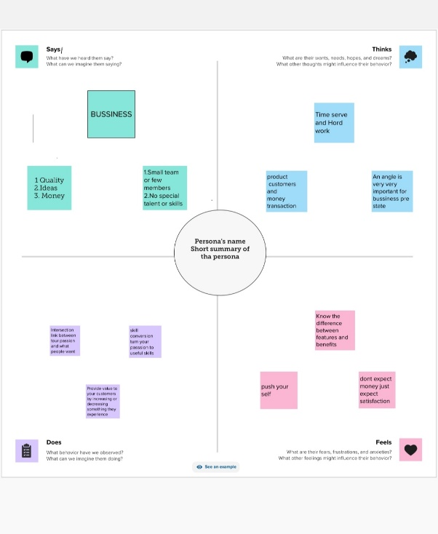

* 1. **IDEATION AND BRAINSTORMING MAP**

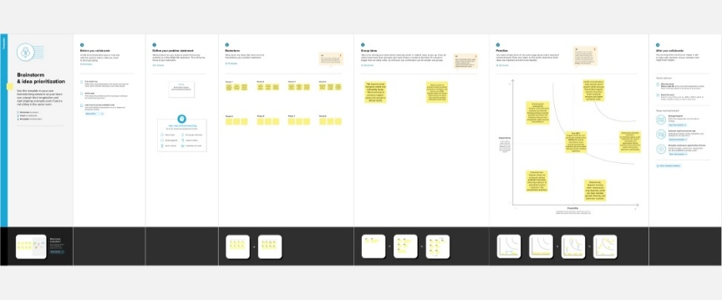

1. **RESULT**

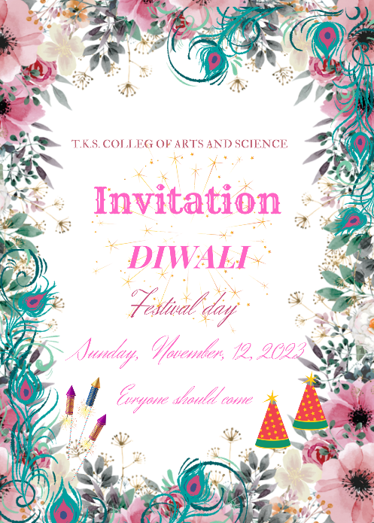

1. **ADVANTAGES AND DISADVANTAGES**

Advantages

Help you maintain friendships and build a stronger connection between you and people who you would like to know.

Disadvantages

Just as there are advantages to using online wedding invitation, there are a few main

Disadvantages as well. While these are not drastic setback, they may mean that you have to send a paper invitation to a few select guests.

1. **APPLICATION**

Address your card to the person you re inviting them to spell out the date time and location and provide contact details so they can RSVP.

1. **CONCLUSION**

Through using CANVA and creating the project we learnt many creative things and it develops innovative. Thoughts in us. We came to know many different templates and how to select the color combinations. And we came to know about variety of graphics design and animations.